SANJIVANI COLLEGE OF ENGINEERING, KOPARGAON
(An Autonomous Institute Affiliated to SPPU Pune)

A SEMINAR REPORT ON
“Predictive Maintenance of Industrial Equipment’s using IoT and Machine Learning”

SUBMITTED TOWARDS THE
PARTIAL FULFILLMENT OF THE REQUIREMENT OF
DEGREE OF BACHELOR OF TECHNOLOGY
IN INFORMATION TECHNOLOGY
BY

Mr. Suyog Balu Dighe [UIT21M1009]
Ms. Arya Subhash Jadhav [UIT21M1019]
Mr. Pramod Sanjay Katare [UIT21M1029]
Ms. Harshada Ravindra Limbhure [UIT21M1039]
Mr. Tushar Sudhakar Patekar [UIT21M1049]
Ms. Bushraa Akbar Humayoon Shaikh [UIT21M1059]
Mr. Ritesh Prashant Gaikwad [UIT21M1069]

UNDER THE GUIDANCE OF

Dr. N. S. Patankar



Sanjivani Rural Education Society’s
Sanjivani College of Engineering, Kopargaon - 423 603
Department of Information Technology
ACADEMIC YEAR 2022-2023

CERTIFICATE

This is to certify that the Seminar report entitled
Predictive Maintenance of Industrial Equipment’s using IoT and Machine Learning
Submitted by
Mr. Suyog Balu Dighe [UIT21M1009]
Ms. Arya Subhash Jadhav [UIT21M1019]
Mr. Pramod Sanjay Katare [UIT21M1029]
Ms. Harshada Ravindra Limbhure [UIT21M1039]
Mr. Tushar Sudhakar Patekar [UIT21M1049]
Ms. Bushraa Akbar Humayoon Shaikh [UIT21M1059]
Mr. Ritesh Prashant Gaikwad [UIT21M1069]
is a bonafide work carried out by the students under the supervision of Dr. N S. Patankar and it is submitted towards the partial fulfillment of the requirement of Bachelor of Technology in Information Technology

Dr. N S Patankar  [Guide] | S.Muthuraj  [Seminar Coordinator] | Dr. M. A. Jawale  [H.O.D IT Department]
Dr. A G Thakur
[Director]
Name & Signature of Internal Examiner |  | Name & Signature of External Examiner

ACKNOWLEDGEMENT

We feel great pleasure in submitting the report on “Predictive Maintenance of Industrial Equipment’s using IoT and Machine Learning" We are highly thankful for the cooperation extended by Dr. N S Patankar Sir for giving comments for the guidance and improvement of work. We would like to thank Prof. S Muthuraj (Seminar Coordinator) for the encouragement and help during the completion of the seminar work. We would like to personally thank Dr. M.A. Jawale (Head of IT Dept.) for providing us with all the necessary facilities to successfully complete the project.

Mr. Suyog Balu Dighe [UIT21M1009]
Ms. Arya Subhash Jadhav [UIT21M1019]
Mr. Pramod Sanjay Katare [UIT21M1029]
Ms. Harshada Ravindra Limbhure [UIT21M1039]
Mr. Tushar Sudhakar Patekar [UIT21M1049]
Ms. Bushraa Akbar Humayoon Shaikh [UIT21M1059]
Mr. Ritesh Prashant Gaikwad [UIT21M1069]

S.Y B.Tech. Information Technology

Contents
Sr. No. Name Pg. No.

1 | Introduction |  | 5
2 | Literature Survey |  | 6
3 | Proposed system |  | 7
4 | Limitations of the base system |  | 11
5 | Conclusion and future scope |  | 12
6 | References |  | 13

- INTRODUCTION

Our quality of life is to be improved via the Internet of Things (IoT). Practically every industry has benefited from it in some way since its launch. IoT, for instance, is widely utilized. For smart housing, the grid smart industry smart agriculture, smart healthcare, and other industries. For efficient productivity, the smart industry, also known as Industry 4.0, uses information and communication technologies. Recently, a lot of research has been focused on IoT, also known as Industrial IoT (IIoT) in the commercial context. Various sensors are utilized in the IIoT to monitor the operation of machinery and even entire production processes.
In IIoT, several sensors are used to track the performance of machinery or perhaps an entire production cycle. Predictive Maintenance (PM), a technique in IIoT, has recently gained popularity. PM's fundamental tenet is to keep an eye on equipment health using the Giacomo Vertical served as the associate editor in charge of overseeing this manuscript's review and giving final approval for publication. Assistance from sensing data to predict likely machine failure or degradation in the future. On the gathered data, PM applies Machine Learning (ML) to produce predictions. The obtained data is what determines how accurate the ML models are. Recently, the IIoT technique of Predictive Maintenance (PM) has gained interest.
A common technique for gathering data in the IIoT is streaming it from sensing devices to the cloud, where it is analyzed and analyzed. Sensing technology usually generates enormous amounts of data in a relatively short length of time, either continuously or intermittently. Thousands of records could be produced by a machine in less than a second, for instance. According to the Cisco cloud index (2013–2018), an automated facility is capable of producing a terabyte of data every hour. This is accomplished by using techniques including filtering, compression, and sampling. These techniques allow for a reduction in the amount of data transferred to the cloud. There can be accuracy trade-offs for ML models that employ smaller datasets.

- LITERATURE SURVEY

To prevent unplanned downtime and lower maintenance costs, predictive maintenance is a proactive approach to equipment maintenance that seeks to identify probable failures before they happen. By enabling real-time data gathering, analysis, and decision-making, the integration of the Internet of Things (IoT) with machine learning techniques has revolutionized the field of predictive maintenance. In this review of the literature, we examine significant studies and developments in the use of IoT and machine learning for industrial equipment predictive maintenance. The literature review highlights the significance of combining IoT and machine learning for the predictive maintenance of industrial equipment. It covers various aspects, including IoT-enabled condition monitoring, machine learning techniques, feature engineering, sensor selection, anomaly detection, and fault diagnosis. The reviewed studies contribute to the advancement of predictive maintenance strategies, providing valuable insights for researchers and practitioners in the field.

IoT and machine learning technologies are discussed, along with the definition of predictive maintenance and its applications in the industry. IoT and machine learning should be used to enable data-driven preventative maintenance solutions. IoT sensor technologies are studied for real-time data collection and condition monitoring. Analysis of various temperature, vibration, and audio condition monitoring sensor kinds. A discussion of the utilization of wireless sensor networks and edge computing for efficient data collection and processing. Data analytics and feature extraction: Machine learning methods are evaluated for pattern recognition and data analysis in predictive maintenance. Comparison of methods for supervised and unsupervised learning to find anomalies and flaws in equipment. A list of methods for extracting relevant characteristics from sensor data using feature extraction algorithms. Identification and prognosis of errors Review of fault identification methods based on machine learning. To ascertain the remaining useful life (RUL) of industrial equipment, prognostic models are investigated. Discussion of the integration of anomaly detection with time-series analysis for defect diagnosis and prediction. IoT and machine learning-based decision-support systems for preventative maintenance are explored in this section on decision-support technologies. An explanation of how to plan maintenance and maximize equipment uptime. Evaluating predictive maintenance solutions' return on investment (ROI) and cost-benefits. Issues and Recommendations for Action: There are problems with data quality, scalability, cybersecurity, and other aspects of implementing IoT and machine learning for predictive maintenance. Exploration of future research directions and trends, such as edge intelligence, explainable AI, and hybrid modeling strategies.

- PROPOSED SYSTEM
Materials and Methods:
Utilizing the Internet of Things to acquire and analyze data regarding assets, machinery, or equipment is known as IoT predictive maintenance. Data regarding the condition of the equipment is gathered by sensors and other instruments to identify any potential problems. The Internet of Things is frequently used in IoT predictive maintenance to monitor a variety of variables that could potentially point to equipment problems. These sensors and monitors are either installed on or incorporated into equipment. These devices collect asset data and send it over the network to other "things" like CMMS software, predictive maintenance software, or other intelligent manufacturing systems.
Other Internet of Things (IoT) technologies can run predictive maintenance analytics to find any potential problems that could lead to equipment failure by collecting and transmitting equipment performance data in real-time. Organizations can use this process to more accurately forecast the likelihood of outages and other disruptions so they can plan for repair. Unnecessary downtime and upcoming outages.
Methodology:
Data collection: Industrial equipment is equipped with IoT sensors to gather a variety of data, including temperature, pressure, vibration, current, and other pertinent factors. These sensors produce real-time data while continuously monitoring the machinery.
Data Transmission: The gathered data is sent to a centralized system or cloud platform for storage and analysis. Depending on the specific needs and equipment, this can be accomplished using wired or wireless communication protocols.
Data preparation is the process of cleaning, normalizing, and transforming data into a format that is acceptable for analysis once it has been received. Outliers may need to be eliminated, missing values may need to be handled, and the data may need to be scaled properly.
In feature engineering, the behavior and performance characteristics of the equipment are captured by extracting pertinent features from the pre-processed data. Statistics, the outcomes of frequency domain analysis, or any other domain-specific parameters can all be included in these features.
Model Training: Historical data that includes both typical operating settings and known failure events is used to train machine learning algorithms. The retrieved attributes and the equipment's state of health are related to patterns and relationships that the algorithms learn.
Anomaly Detection: After the models have been trained, they are used to anticipate the equipment's current state of health. Continuously updated sensor data is supplied into the models, and any departures from the standard are recognized as potential abnormalities or warning indicators of impending failure.
When the predictive models identify anomalies or foresee possible failures, alerts or notifications are generated. By scheduling repairs or replacements in advance of a breakdown, maintenance professionals can use this knowledge to arrange maintenance actions proactively.
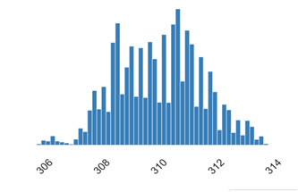
Figure 1: A sample line graph that shows Process temperature [K] and Real Number (R)

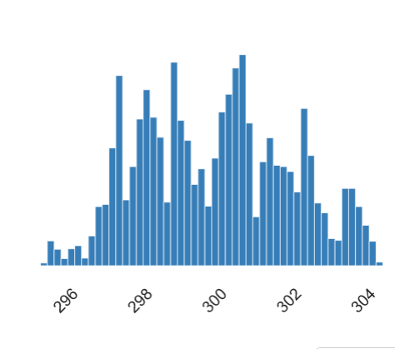
Figure 2: A sample line graph that shows Air temperature [K] and Real Number (R)

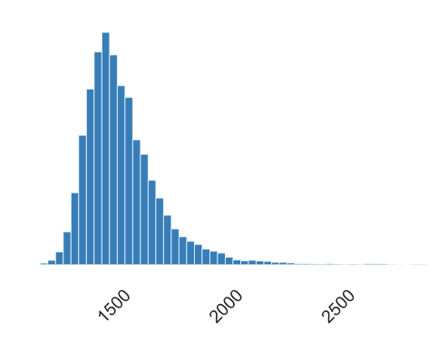

Figure 3: A sample line graph that shows Rotational Speed [rpm] and Real Number[R]

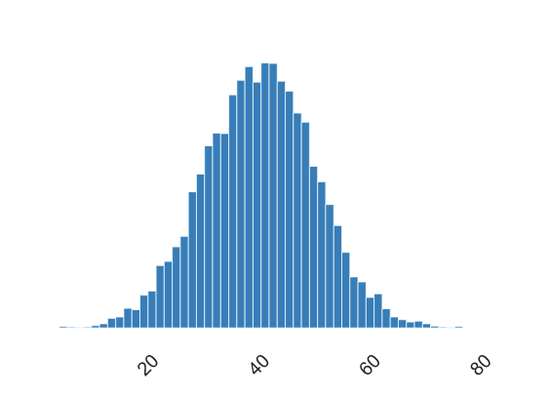
Figure 4: A sample line graph that shows Torque [Nm] and Real Number (R)

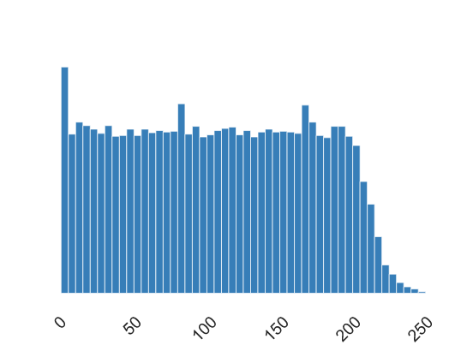
Figure 5: A sample line graph that shows Tool Wear [min] and Real Number (R)

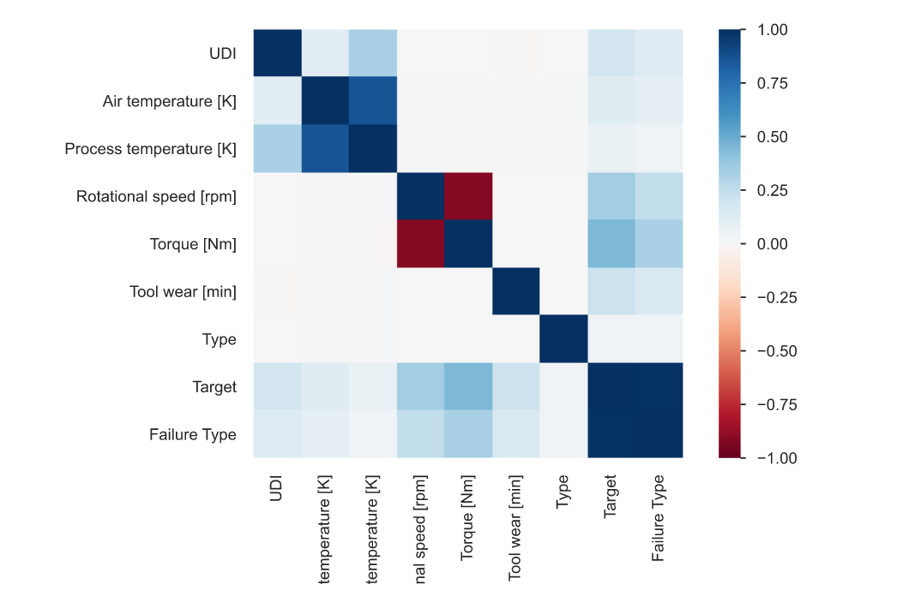

Figure 6: Heat-map [Correlations]

PROPOSED WORK

Increased Maintenance Efficiency: By utilizing real-time data and predictive analytics, industries may more efficiently deploy resources and optimize their maintenance plans. This results in less downtime and more operational effectiveness.
Cost savings: Preventative maintenance helps businesses avoid expensive unplanned outages and last-minute repairs. Maintenance tasks can be planned and carried out more effectively, lowering overall maintenance costs, by anticipating future problems.
Predictive maintenance enables the early identification of possible equipment faults, increasing equipment reliability. The lifespan and dependability of industrial equipment can be greatly increased by fixing problems before they result in serious damage.
Enhanced Safety: Workplace safety is improved by spotting and fixing equipment issues before they cause incidents or accidents. Predictive maintenance can aid in preventing serious malfunctions that could endanger workers and the environment.
Improved Inventory Management: Predictive maintenance can offer information about the availability of spare parts and consumption trends. Better inventory management is made possible by this information, which guarantees that the necessary parts are always on hand when needed and lowers the price of keeping inventory on hand.
Making decisions based on data: The application of IoT and machine learning for preventative maintenance provides a plethora of data. Organizations can use this data to detect patterns, improve processes, and come to wise strategic judgments by leveraging it for further analysis and decision-making.
Customers will be more satisfied since businesses can offer them a more reliable, consistent service by reducing downtime and increasing equipment reliability. Customers will be more satisfied, and relationships will be strengthened.
Continuous Improvement: In predictive maintenance, the feedback loop enables the models and algorithms to be improved continuously. The system may learn from previous mistakes and can become more accurate and reliable over time as more data becomes available and maintenance tasks are carried out.
It's vital to remember that the precise outcomes can change depending on the sector, tools, data caliber, and execution strategy. Overall, though, using predictive maintenance through the IoT and machine learning has the potential to significantly improve maintenance procedures across industries.

- LIMITATIONS OF BASE SYSTEM

Continuous Improvement: The system can gather input on the accuracy of forecasts and modify the models when fresh data becomes available and maintenance tasks are carried out. This iterative process gradually increases the predictive maintenance system's accuracy and dependability.

- CONCLUSION AND FUTURE SCOPE

Conclusion:
The integration of IoT and machine learning in predictive maintenance offers increased efficiency, cost savings, enhanced equipment reliability, improved safety, better inventory management, data-driven decision-making, customer satisfaction, continuous improvement, and the potential for transformative optimization in industrial equipment maintenance processes.
Future Scope:

Reduced Downtime: By anticipating failures, maintenance tasks can be conducted during downtime that is scheduled, reducing unplanned shutdowns and their related costs.
Cost savings: Predictive maintenance optimizes maintenance plans, minimizing the need for expensive emergency repairs and unneeded maintenance actions.
Extended Equipment Lifespan: By taking care of problems before they become serious, proactive maintenance procedures can increase the lifespan of industrial equipment.
Greater Operational Efficiency: Predictive maintenance allows for improved resource allocation because it focuses maintenance efforts on the equipment that requires them, saving time and resources on pointless inspections.
Enhanced Safety: By decreasing the likelihood of accidents or incidents brought on by malfunctioning equipment, anticipating future equipment failures enhances safety.

- REFERENCES

- IoT-enabled Condition Monitoring:
a.Gao, R., et al. (2018). "A Review on Data-Driven Approaches for Industrial Process Monitoring and Fault Diagnosis." IEEE Transactions on Industrial Electronics. This study provides an overview of data-driven approaches for monitoring industrial processes and fault diagnosis, highlighting the integration of IoT sensors and data analytics techniques.
b. Zhou, K., et al. (2019). "An IoT-Based Approach for Real-Time Monitoring and Predictive Maintenance of Equipment in Smart Factories." Sensors. The authors propose an IoT-based framework for equipment monitoring and maintenance in smart factories, utilizing sensor data fusion, machine learning algorithms, and cloud computing.

- Machine Learning Techniques for Predictive Maintenance:
a. Zhao, Y., et al. (2019). "A Comprehensive Survey on Industrial Machine Learning for Predictive Maintenance Applications." IEEE Transactions on Systems, Man, and Cybernetics: Systems. This survey paper provides an extensive overview of machine learning techniques, such as support vector machines, random forests, and deep learning, applied to predictive maintenance in industrial settings.
b. Wang, Z., et al. (2020). "A Comparative Study of Machine Learning Algorithms for Predictive Maintenance." Journal of Manufacturing Systems. The authors compare the performance of various machine learning algorithms, including logistic regression, decision trees, and gradient boosting, for predictive maintenance tasks, considering factors such as accuracy and computational efficiency.

- Feature Engineering and Sensor Selection:
a. Vachtsevanos, G., et al. (2015). "Machine Learning in Cyber-Physical Systems: A Brief Overview." Proceedings of the IEEE. This paper presents an overview of feature engineering techniques for cyber-physical systems, emphasizing the importance of sensor selection, signal preprocessing, and feature extraction for effective predictive maintenance.
b. Jia, Y., et al. (2021). "Feature Selection for Predictive Maintenance: A Review and Perspective." Reliability Engineering & System Safety. The authors review feature selection methods used in predictive maintenance, including statistical techniques, dimensionality reduction, and information gain, with a focus on their applicability to IoT-based systems.

- Anomaly Detection and Fault Diagnosis:
a. Saxena, A., et al. (2019). "A Review of Anomaly Detection Techniques for Time Series Data." IEEE Transactions on Big Data. This comprehensive review paper explores various anomaly detection techniques applicable to time series data, which are commonly encountered in industrial equipment monitoring. The authors discuss methods such as statistical approaches, clustering, and deep learning-based anomaly detection.
b. Liu, W., et al. (2021). "A Review of Fault Diagnosis Methods for Industrial Equipment Based on Machine Learning." Journal of Manufacturing Systems. This review paper provides an overview of machine learning-based fault diagnosis methods, including unsupervised, supervised, and semi-supervised approaches, highlighting their application in industrial equipment maintenance.

Machine learning for predictive maintenance of industrial machines using IoT sensor data November 2017 DOI:10.1109/ICSESS.2017.8342870 Conference: 2017 8th IEEE International Conference on Software Engineering and Service Science (ICSESS)

